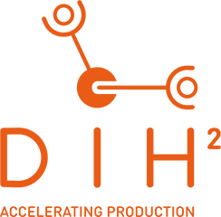

Suggested text to include in Newsletters

A Call to Startups, SMEs and Research Organisations in the Manufacturing Field

Are you looking for a way to make your production adapt to market changes and the needs of your customers? Are you working on robotics solutions for manufacturing companies?

If yes is the answer to one of the questions, keep reading.

The newly launched pan-European programme, DIH², is looking for manufacturing SMEs and Mid-Caps who face Agile Production challenges, as well as technology providers specialised in robotics.

Benefits: up to €248,000 equity-free funding and premium technology transfer services.

Apply before 31 October 2019!

